Freeform Curved Shapes

Definition
# Source: AI Source: Provided by: [Data Path: Persons Table -> ID Column: 1, Name_En Column: Motasem Essam] -> From: [ChatGPT] on [7/25/2026]
Freeform Curved Shapes are shapes whose boundaries consist primarily of curved lines that do not follow a fixed standard geometric form or predetermined regular pattern.
They are freeform because their curves can vary naturally in direction, curvature, size, and shape rather than being restricted to standard curves such as circles, ellipses, or parabolas.
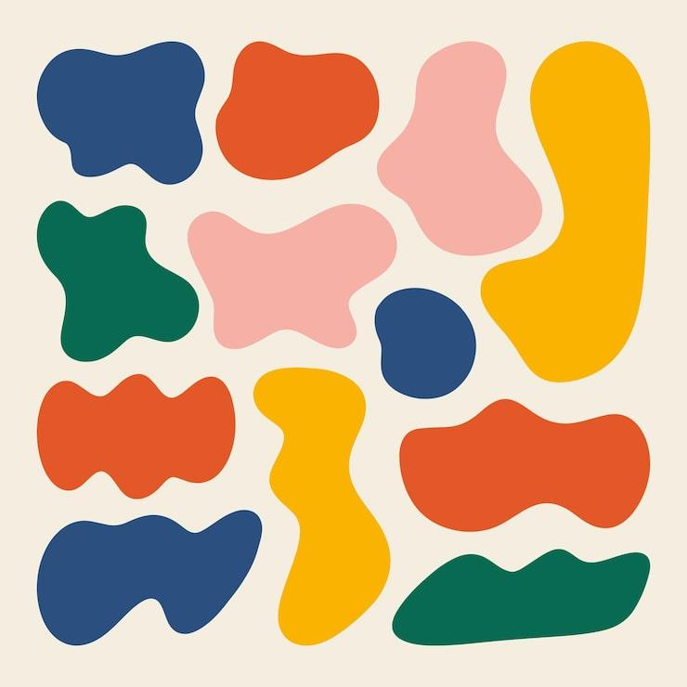
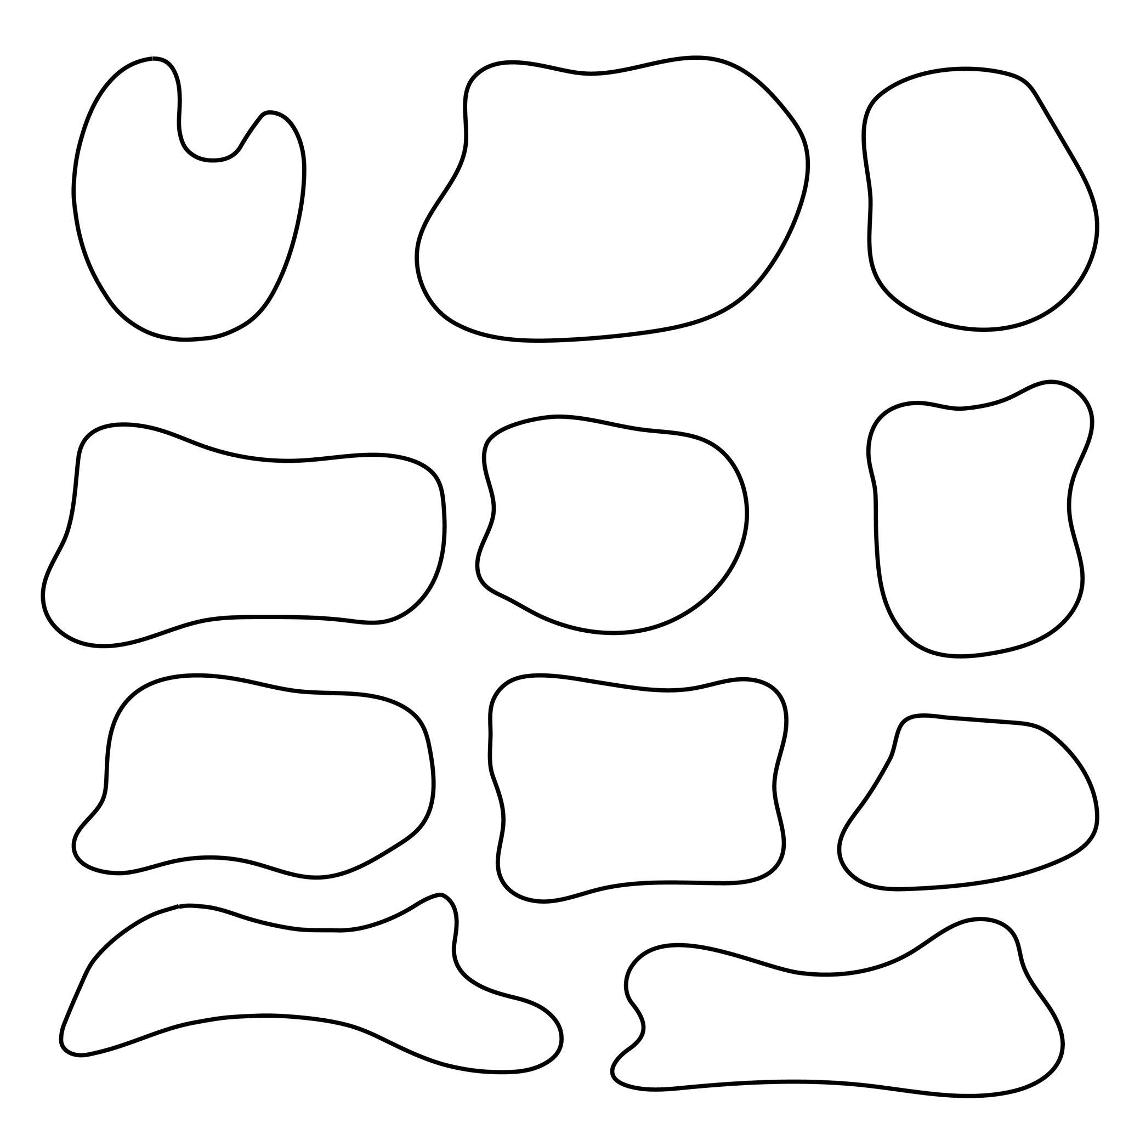
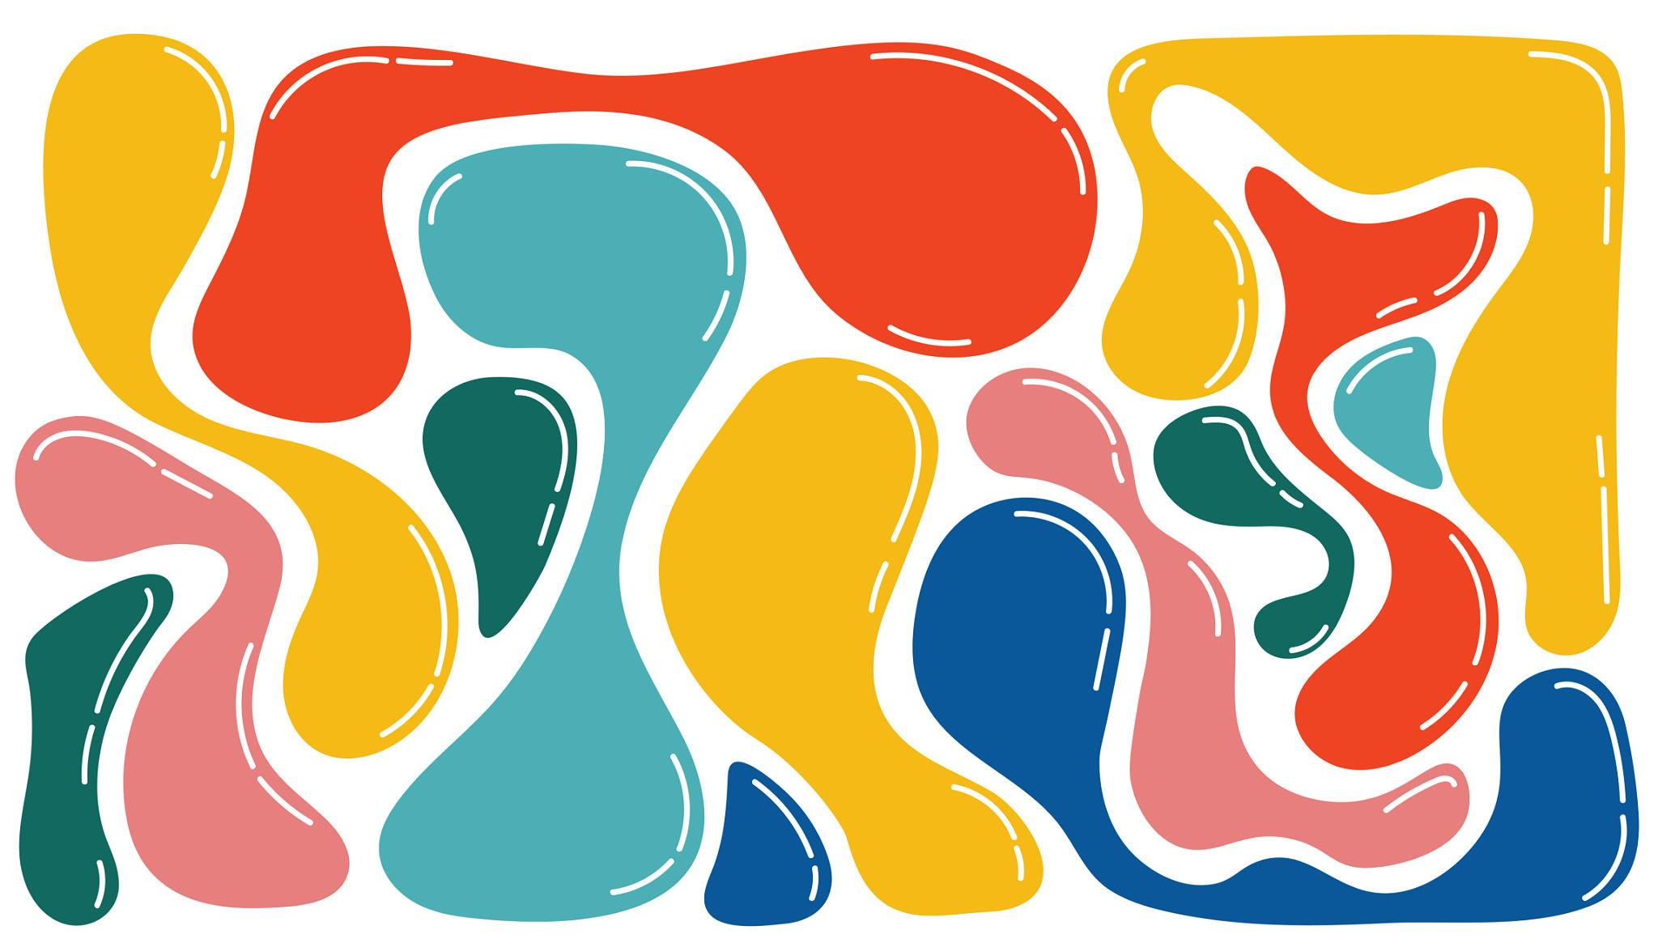
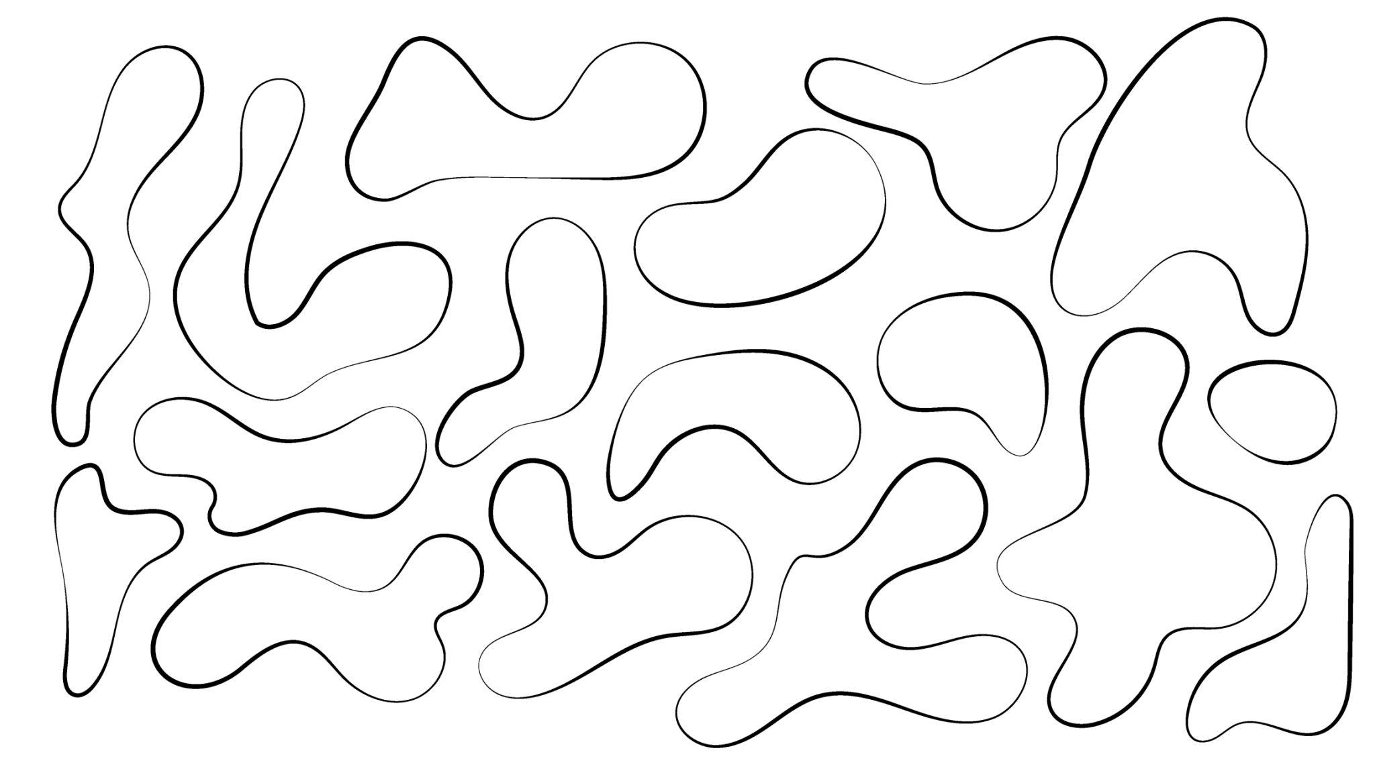
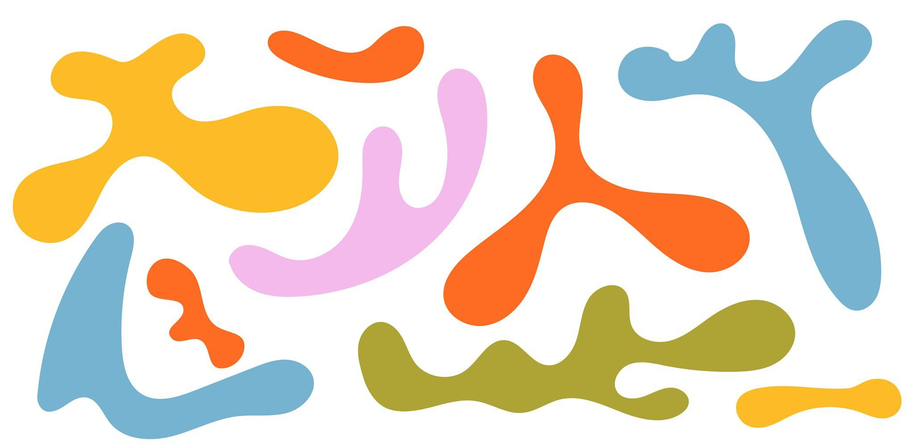

Fundamental Concept
# Source: AI Source: Provided by: [Data Path: Persons Table -> ID Column: 1, Name_En Column: Motasem Essam] -> From: [ChatGPT] on [7/25/2026]
The fundamental idea is:
Curved boundary + no fixed standard geometric form
A freeform curved shape may contain one or many smooth curves.
For example:
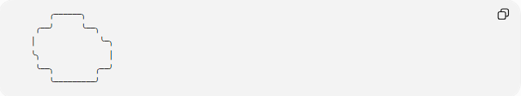
╭──────╮
╭──╯ ╰──╮
│ ╰─╮
╰╮ │
╰──╮ ╭──╯
╰─────────╯
The boundary does not have to conform to a specific standard curve.

Main Characteristics
# Source: AI Source: Provided by: [Data Path: Persons Table -> ID Column: 1, Name_En Column: Motasem Essam] -> From: [ChatGPT] on [7/25/2026]
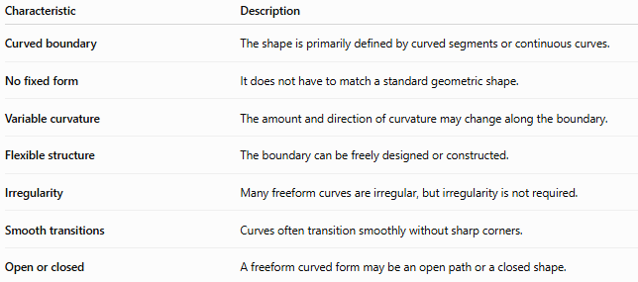
Characteristic | Description
Curved boundary | The shape is primarily defined by curved segments or continuous curves.
No fixed form | It does not have to match a standard geometric shape.
Variable curvature | The amount and direction of curvature may change along the boundary.
Flexible structure | The boundary can be freely designed or constructed.
Irregularity | Many freeform curves are irregular, but irregularity is not required.
Smooth transitions | Curves often transition smoothly without sharp corners.
Open or closed | A freeform curved form may be an open path or a closed shape.

Basic Structure
# Source: AI Source: Provided by: [Data Path: Persons Table -> ID Column: 1, Name_En Column: Motasem Essam] -> From: [ChatGPT] on [7/25/2026]
A freeform curved shape can consist of:
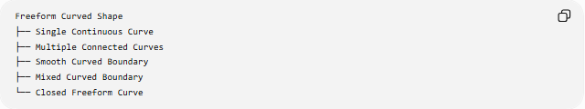
Freeform Curved Shape
├── Single Continuous Curve
├── Multiple Connected Curves
├── Smooth Curved Boundary
├── Mixed Curved Boundary
└── Closed Freeform Curve
A closed freeform curved shape encloses a region:
$$S=\left\{\left(x , y\right)∣\left(x , y\right)\text{ lies inside the closed boundary}\right\}$$

Types of Freeform Curved Shapes
# Source: AI Source: Provided by: [Data Path: Persons Table -> ID Column: 1, Name_En Column: Motasem Essam] -> From: [ChatGPT] on [7/25/2026]
A useful classification is:
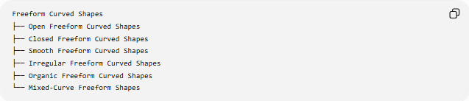
Freeform Curved Shapes
├── Open Freeform Curved Shapes
├── Closed Freeform Curved Shapes
├── Smooth Freeform Curved Shapes
├── Irregular Freeform Curved Shapes
├── Organic Freeform Curved Shapes
└── Mixed-Curve Freeform Shapes
These classifications can overlap.
For example, one shape can simultaneously be:
- Closed
- Smooth
- Irregular
- Organic
- Freeform

Open Freeform Curved Shapes
# Source: AI Source: Provided by: [Data Path: Persons Table -> ID Column: 1, Name_En Column: Motasem Essam] -> From: [ChatGPT] on [7/25/2026]
Open Freeform Curved Shapes have curved paths with distinct endpoints.
They do not enclose a region by themselves.
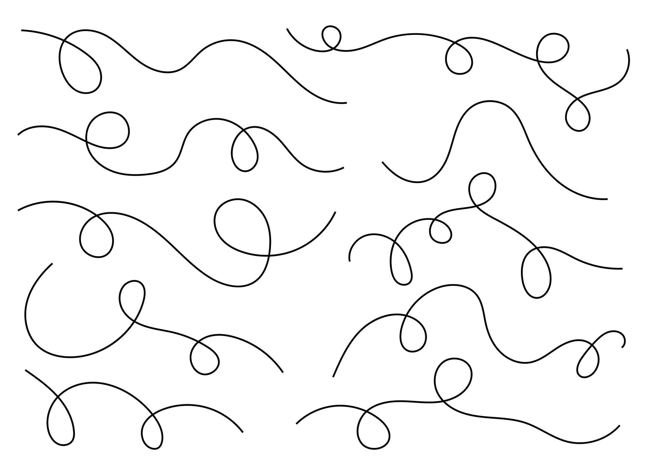
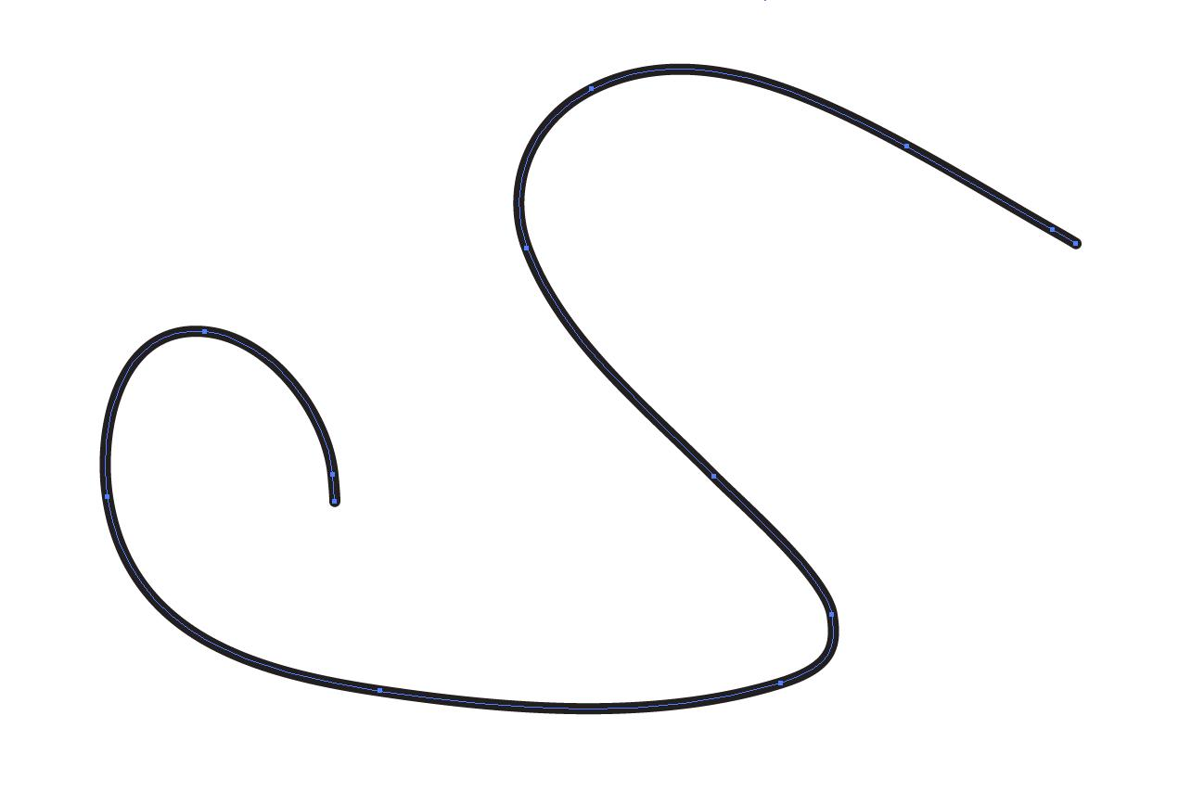
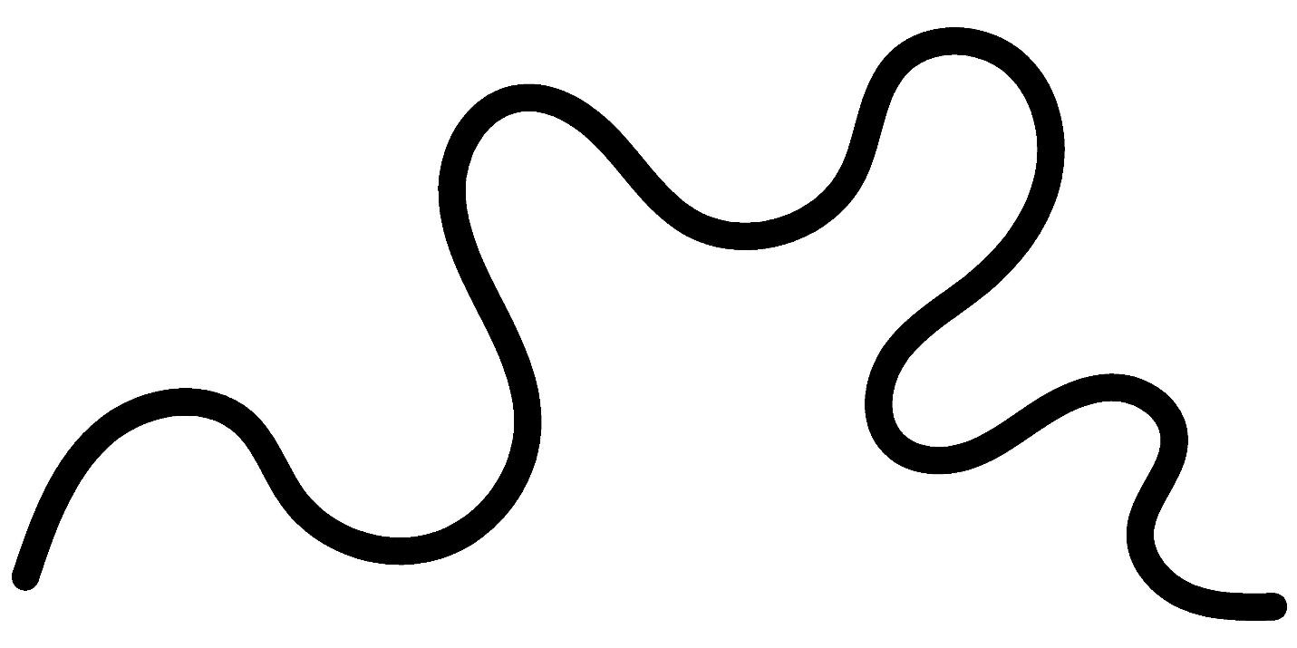
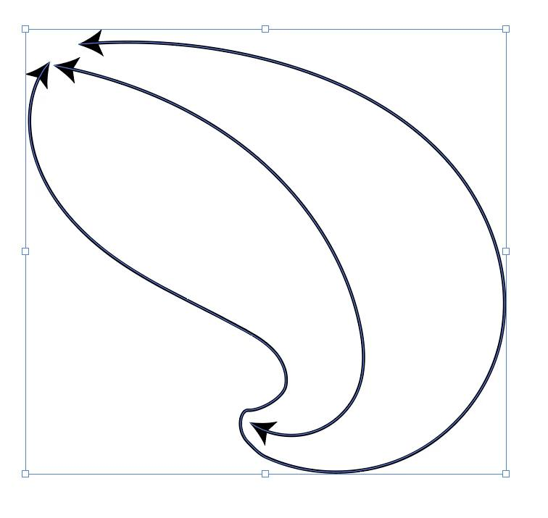
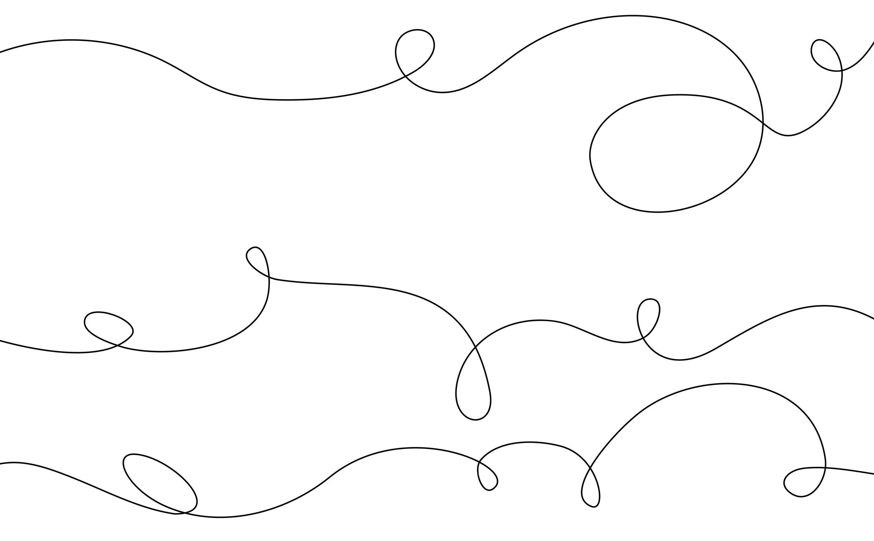
A parametric representation is:
$$r\left(t\right)=\left(x , \left(t\right)y\left(t\right)\right), a≤t≤b$$
with:
$$r\left(a\right)≠r\left(b\right)$$
For a curve $y=f\left(x\right)$, its arc length from $x=a$to $x=b$is:
$$\boxed{L=\int_{a}^{b}{\sqrt{1+{\left(\frac{dy}{dx}\right)}^{2}}} dx}$$

Closed Freeform Curved Shapes
# Source: AI Source: Provided by: [Data Path: Persons Table -> ID Column: 1, Name_En Column: Motasem Essam] -> From: [ChatGPT] on [7/25/2026]
Closed Freeform Curved Shapes have boundaries that return to their starting point and enclose an area.
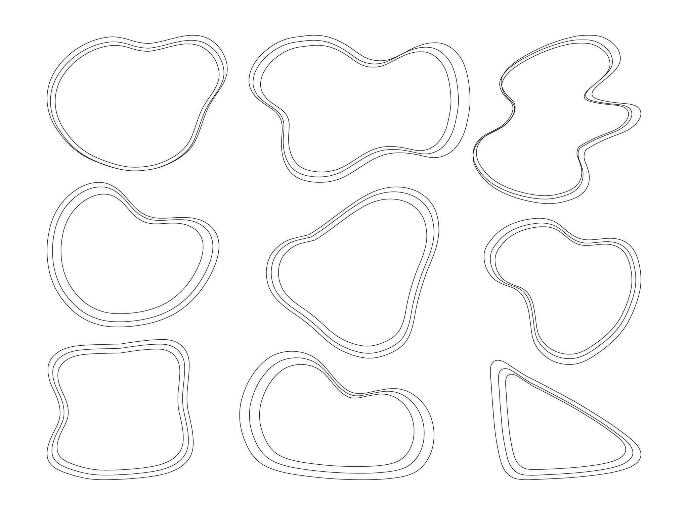
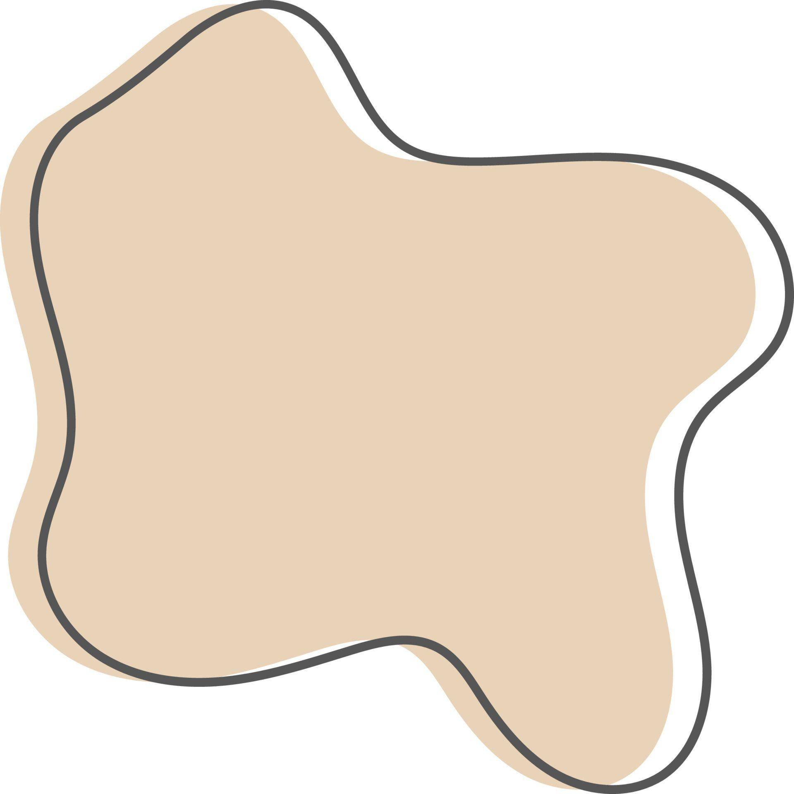
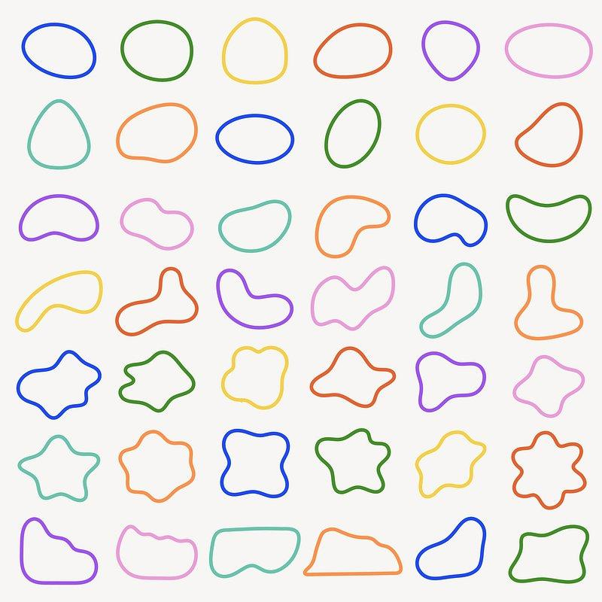
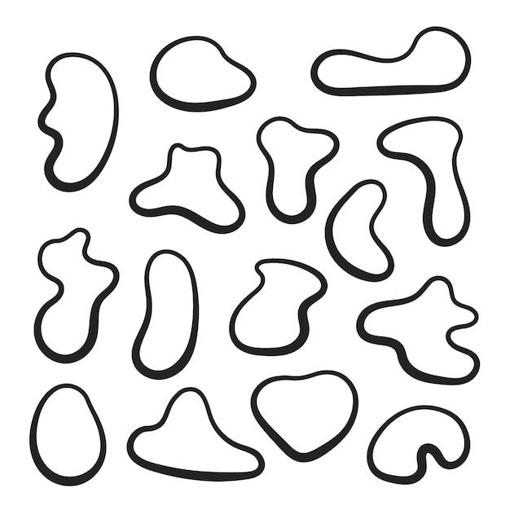
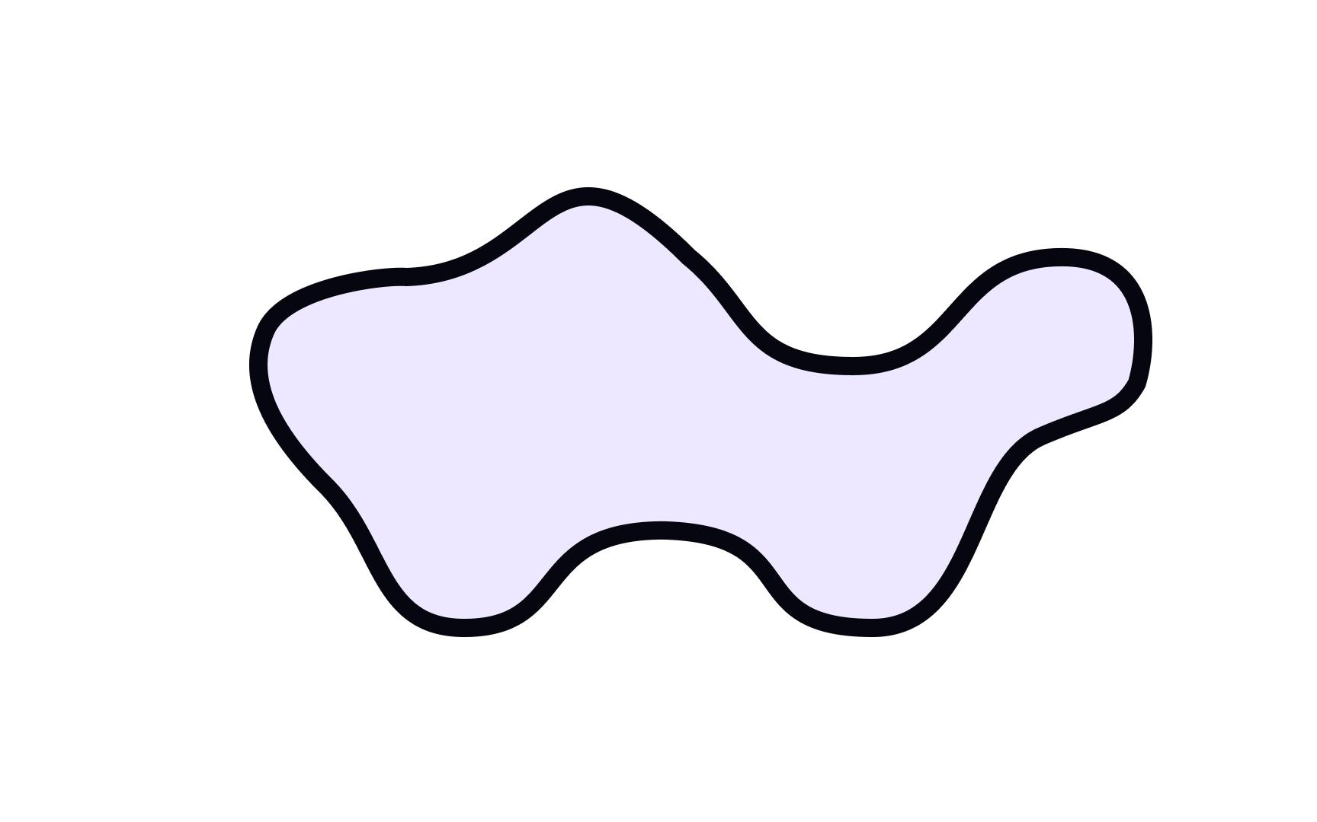
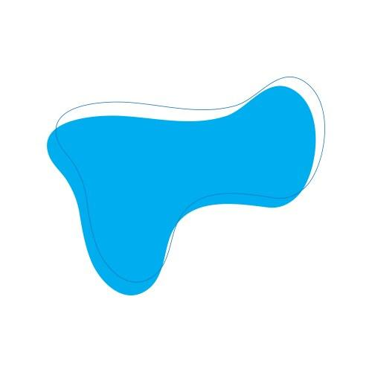
For a parametric boundary:
$$r\left(t\right)=\left(x , \left(t\right)y\left(t\right)\right)$$
closure requires:
$$r\left(a\right)=r\left(b\right)$$
For a simple closed parametric curve, its enclosed area can be calculated using:
$$\boxed{A=\frac{1}{2}\oint{(}\left.x dy-y dx\right)}$$

Smooth Freeform Curved Shapes
# Source: AI Source: Provided by: [Data Path: Persons Table -> ID Column: 1, Name_En Column: Motasem Essam] -> From: [ChatGPT] on [7/25/2026]
Smooth Freeform Curved Shapes have continuously changing directions without sharp corners.
Their curvature can vary along the curve.
For a plane curve $y=f\left(x\right)$, curvature is:
$$\boxed{κ=\frac{∣f^{''}\left(x\right)∣}{{\left(1+{\left[f^{'}\left(x\right)\right]}^{2}\right)}^{3/2}}}$$
Unlike a circle, whose curvature is constant, a freeform curve may have:
$$κ=κ\left(t\right)$$
that changes from one location to another.

Irregular Freeform Curved Shapes
# Source: AI Source: Provided by: [Data Path: Persons Table -> ID Column: 1, Name_En Column: Motasem Essam] -> From: [ChatGPT] on [7/25/2026]
Irregular Freeform Curved Shapes have non-uniform curvature, proportions, or overall structure.
For example:
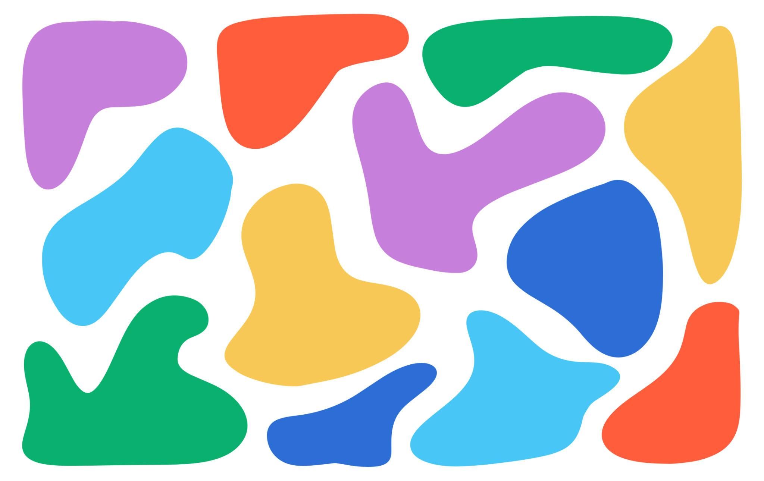
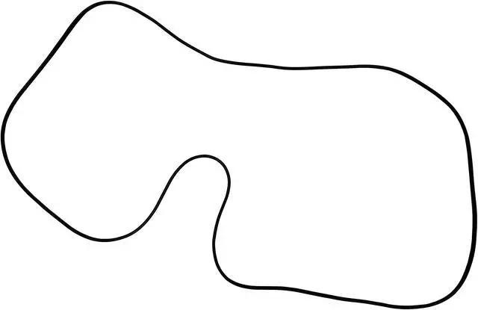
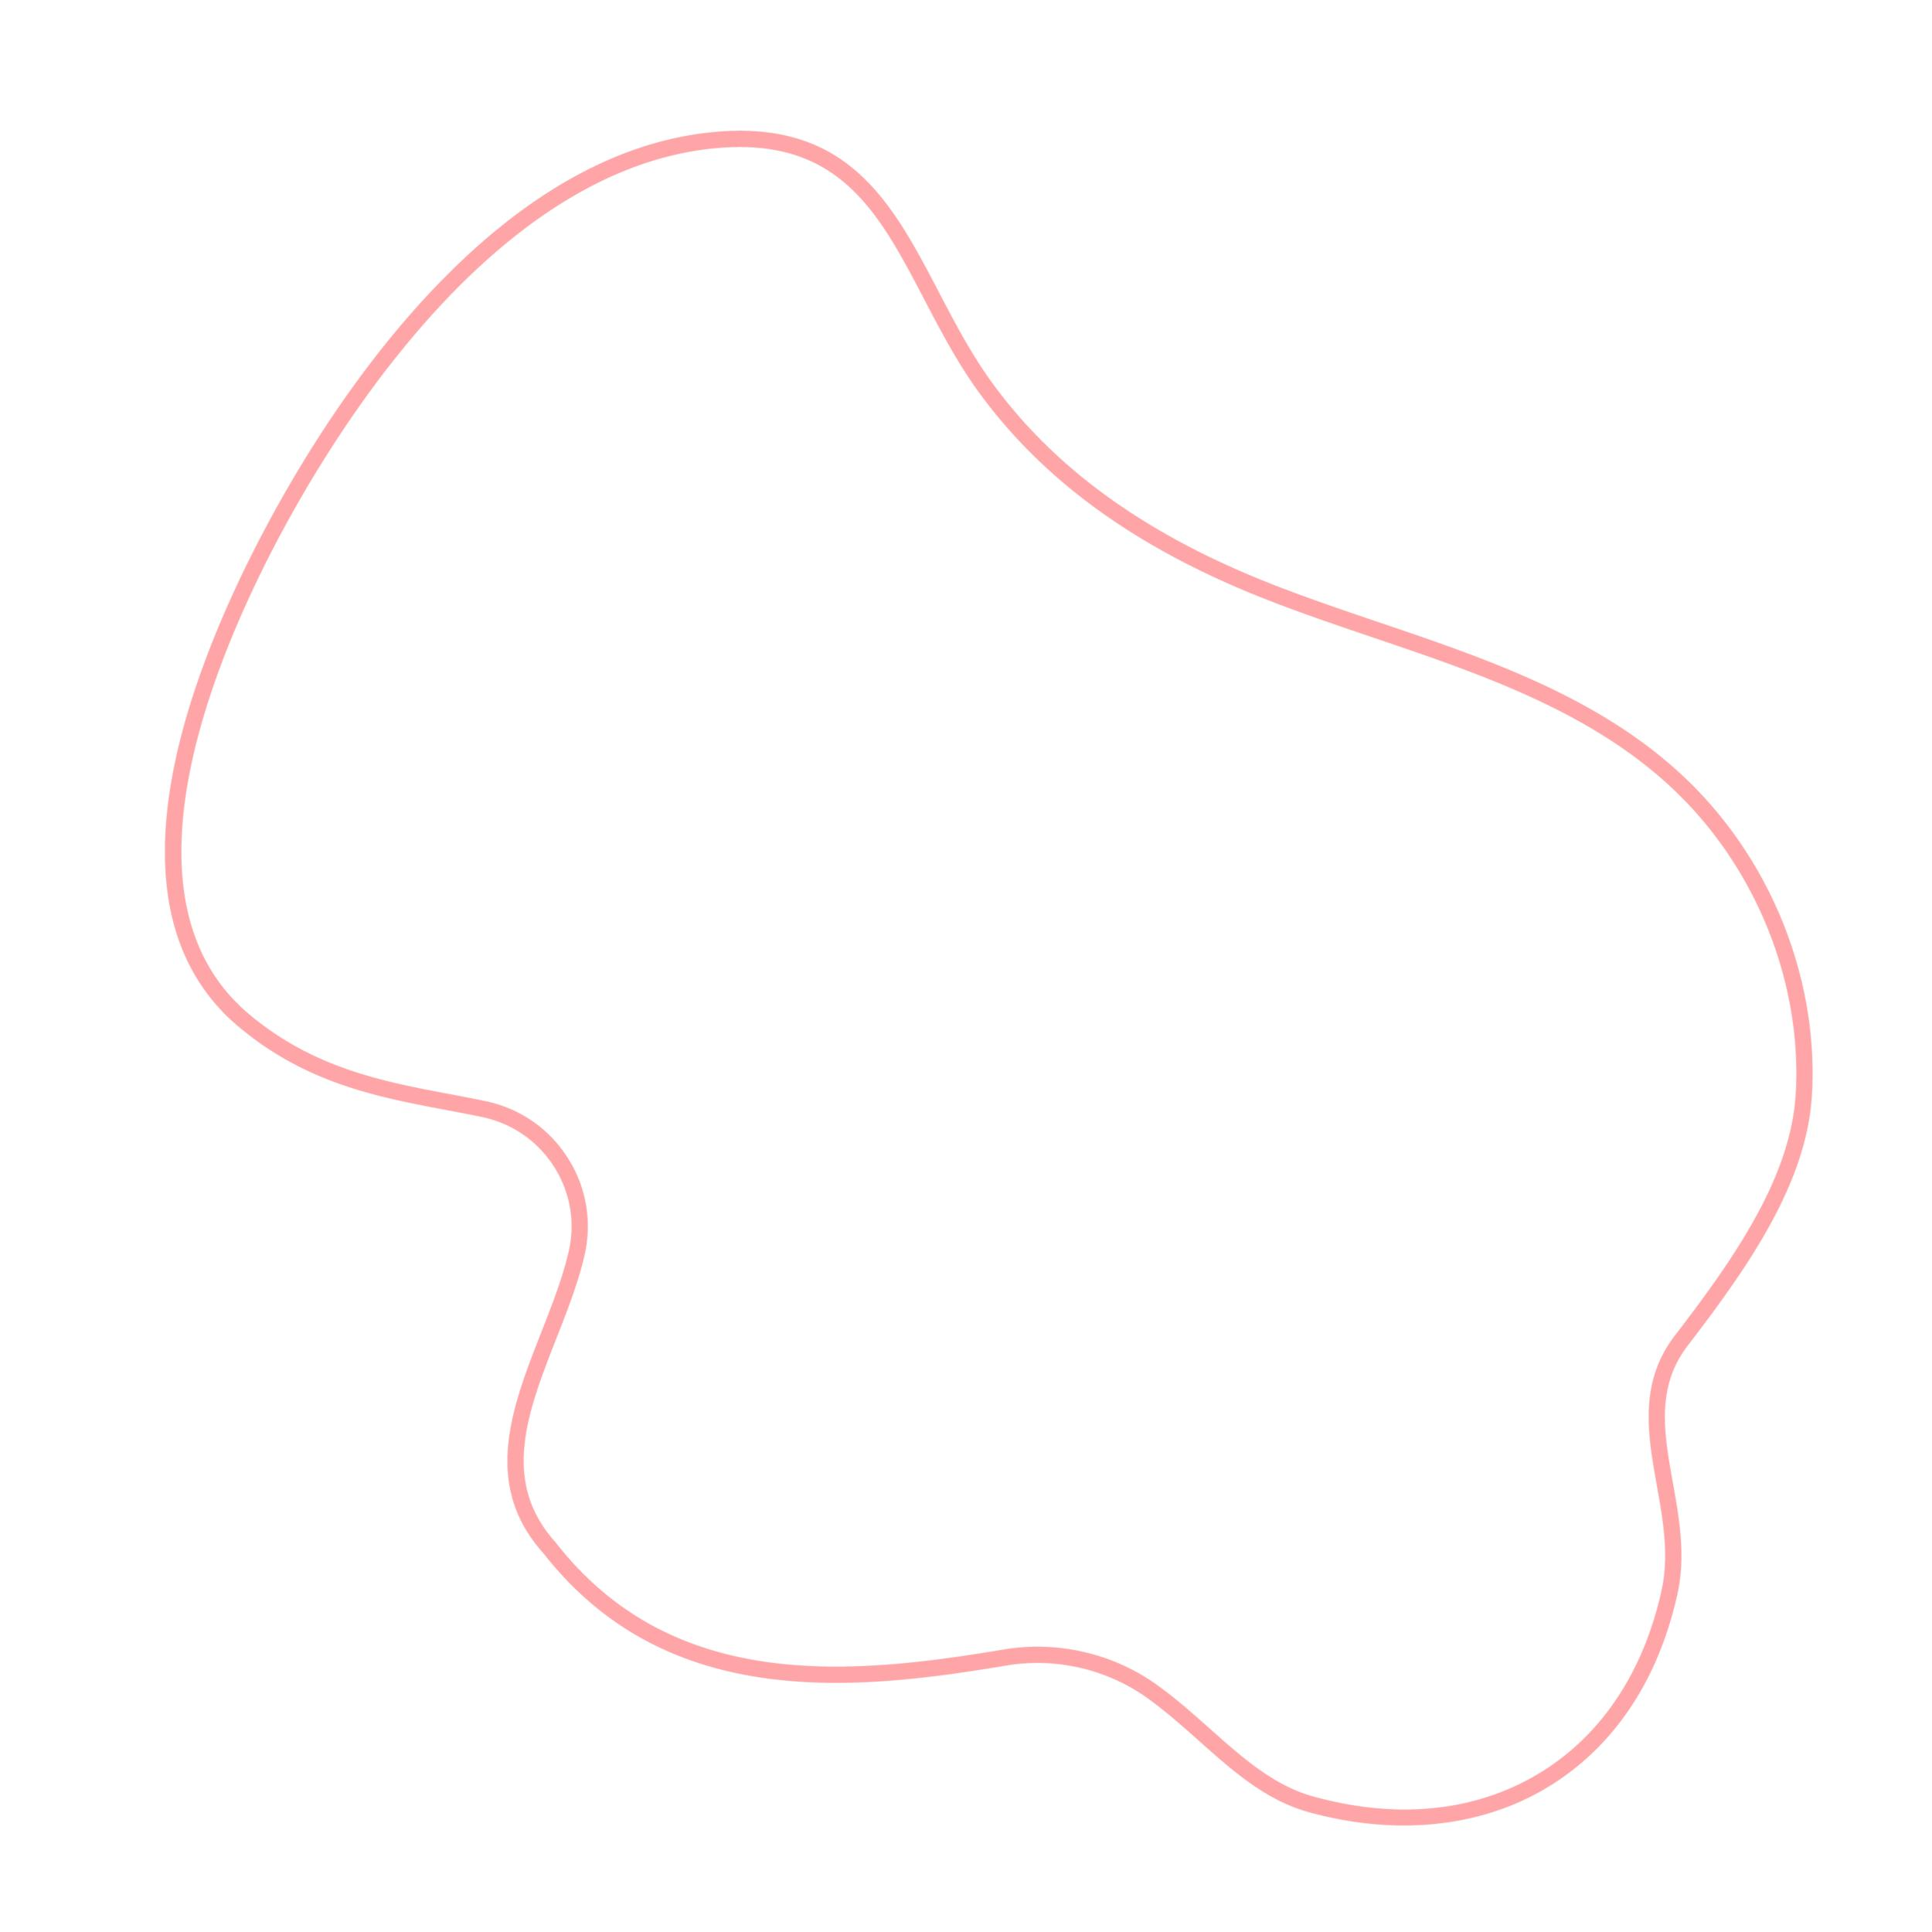
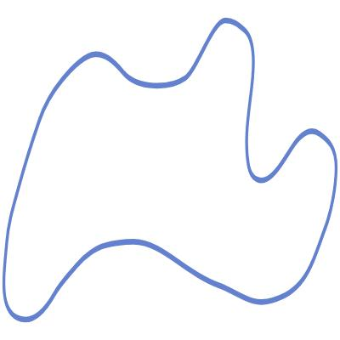
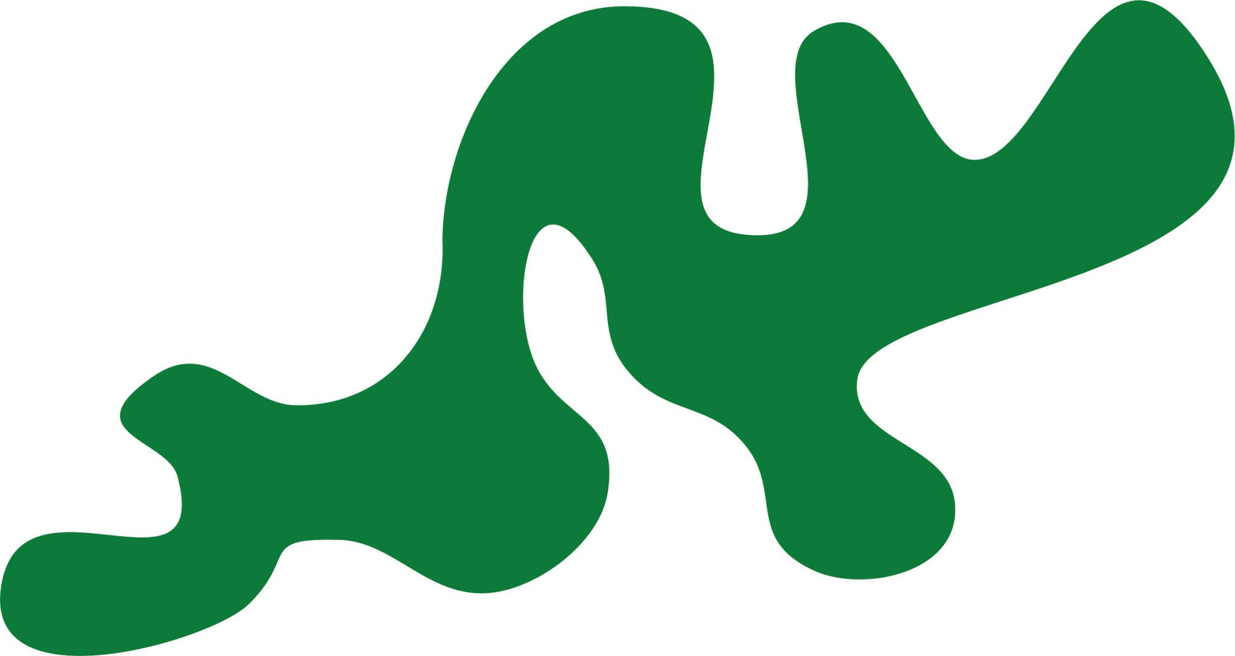
Different parts of the boundary may have different:
- curvature
- lengths
- widths
- directions
- amplitudes
- rates of change
Important distinction
$$\text{Freeform}≠\text{Irregular}$$
A curve can be freeform while still having a deliberately regular or symmetrical structure.

Organic Freeform Curved Shapes
# Source: AI Source: Provided by: [Data Path: Persons Table -> ID Column: 1, Name_En Column: Motasem Essam] -> From: [ChatGPT] on [7/25/2026]
Organic Freeform Curved Shapes combine freeform curved boundaries with an organic, natural, or flowing appearance.
Examples include shapes resembling:
- leaves
- clouds
- water droplets
- natural stones
- petals
- biological forms
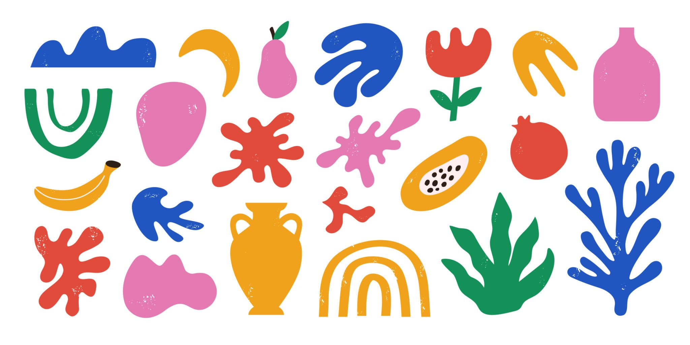
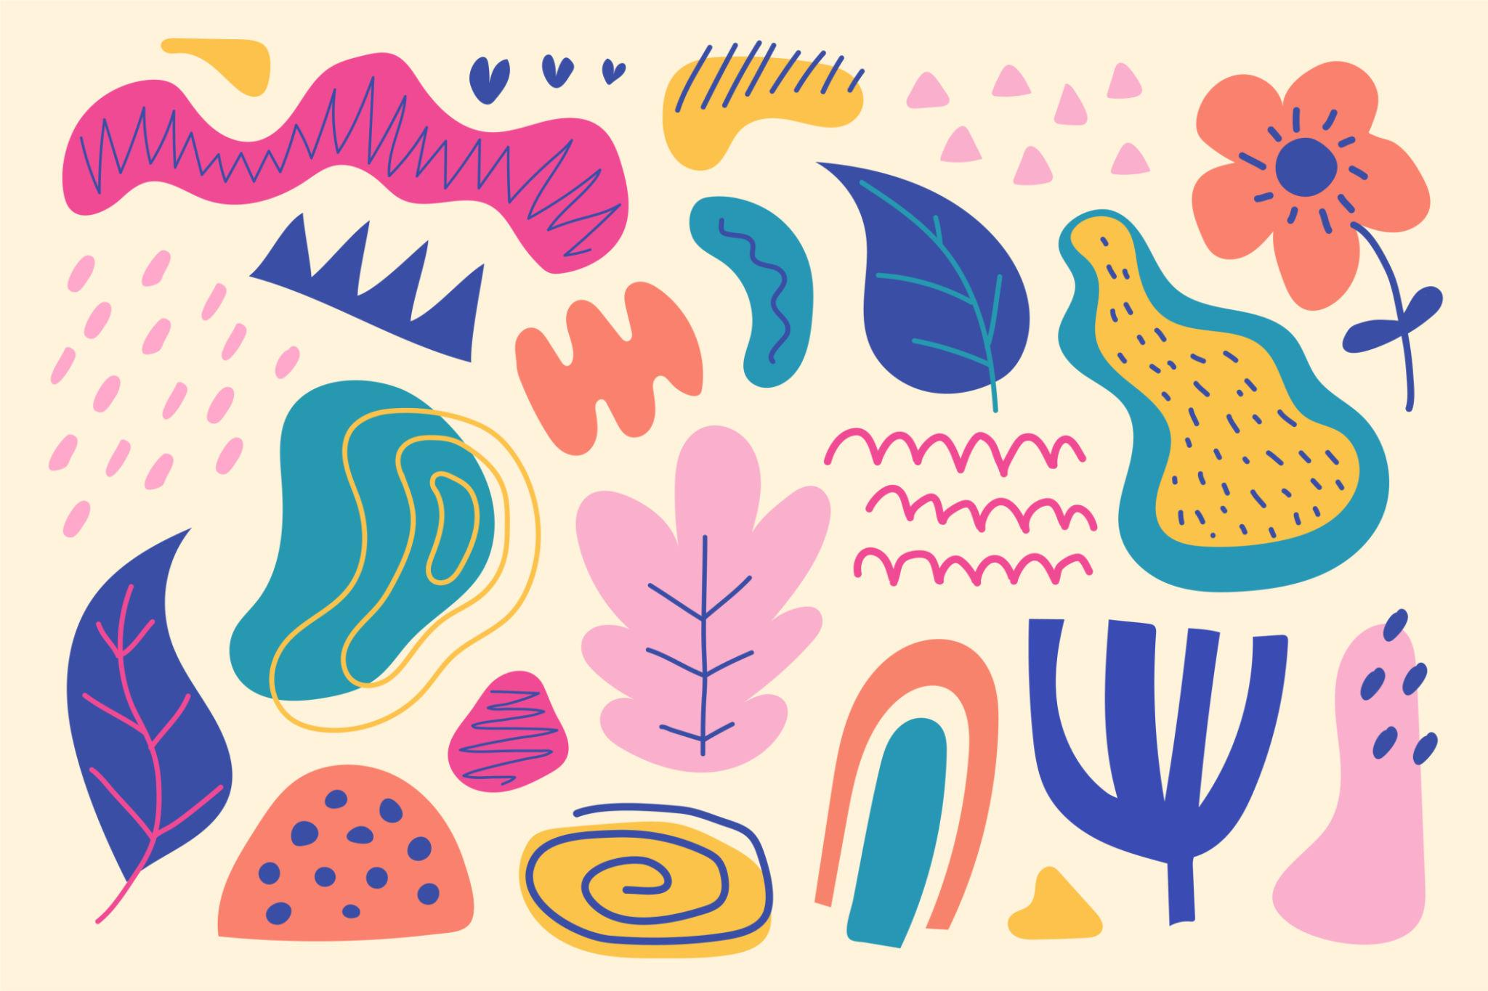
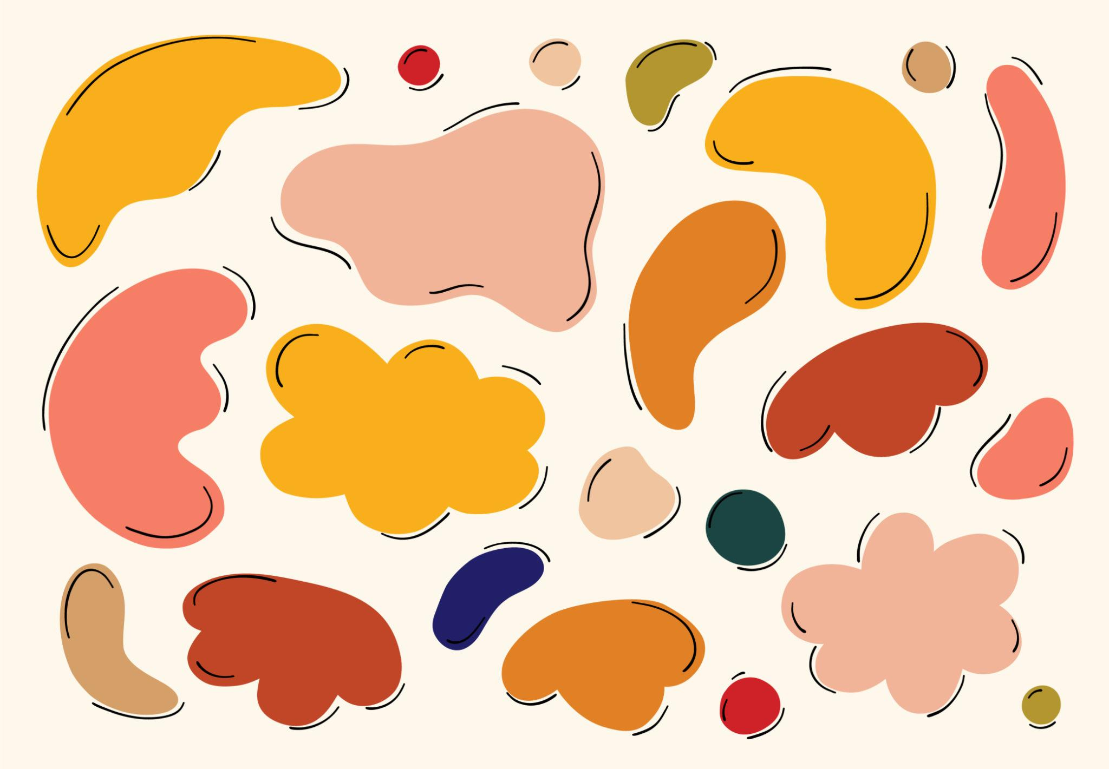
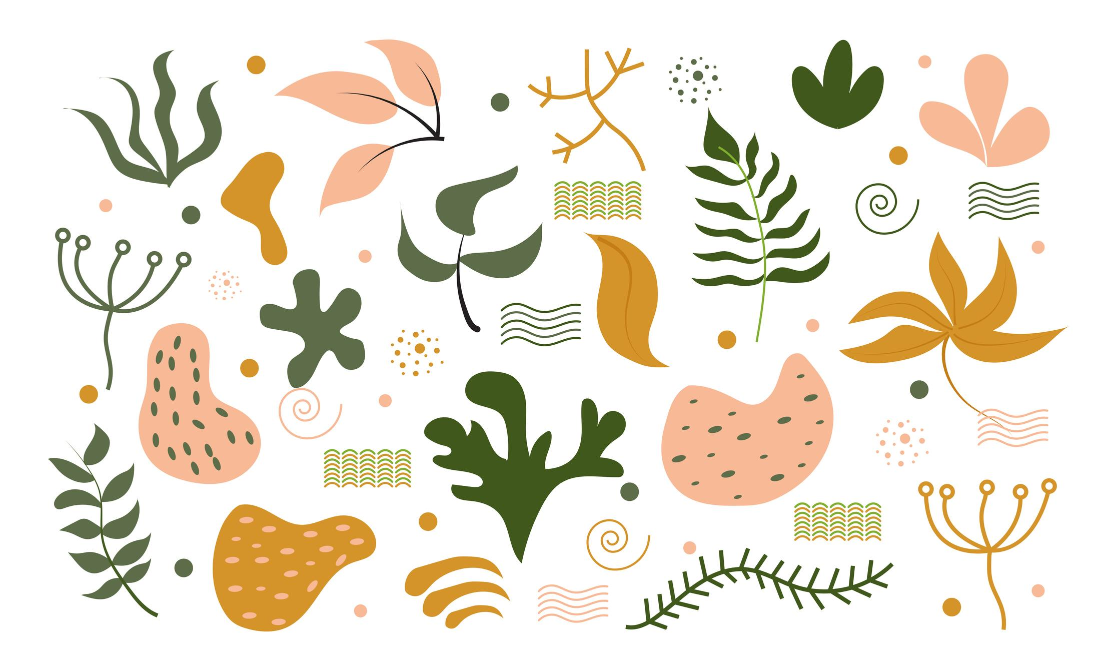
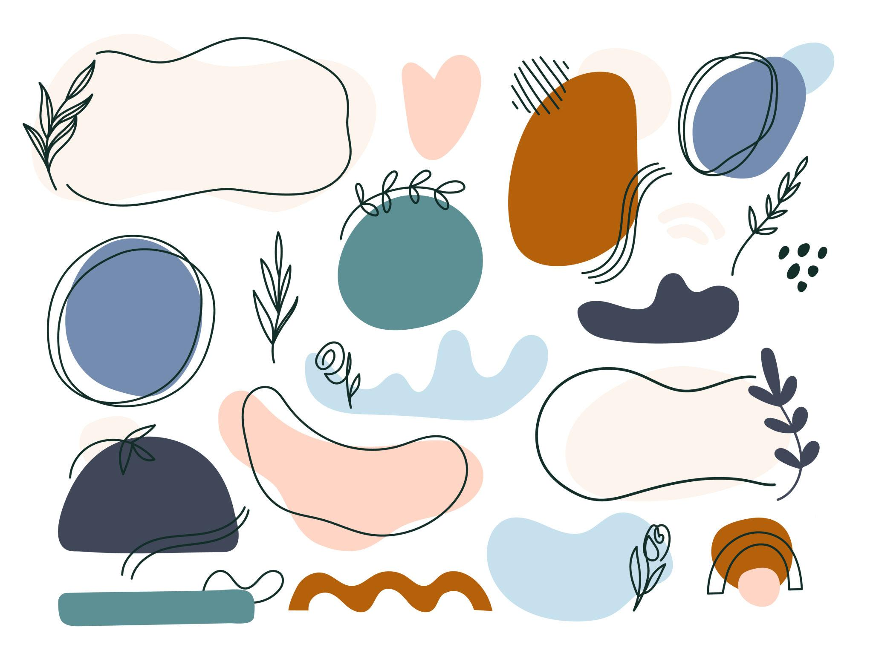
This is primarily a descriptive/design classification, rather than a strict mathematical category.

Mixed-Curve Freeform Shapes
# Source: AI Source: Provided by: [Data Path: Persons Table -> ID Column: 1, Name_En Column: Motasem Essam] -> From: [ChatGPT] on [7/25/2026]
A Mixed-Curve Freeform Shape combines different types of curved portions within one overall boundary.
For example:
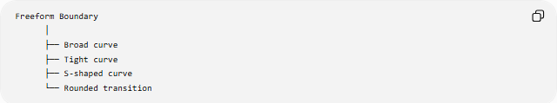
Freeform Boundary
│
├── Broad curve
├── Tight curve
├── S-shaped curve
└── Rounded transition
The individual portions do not necessarily belong to the same standard curve family.
A piecewise representation can be written as:
$$f\left(x\right)=\left\{\begin{matrix}f_{1}\left(x\right), & x≤c \\ f_{2}\left(x\right), & x>c\end{matrix}\right.$$
For a smooth transition at $x=c$, one may require:
$$f_{1}\left(c\right)=f_{2}\left(c\right)$$
and, when differentiability is desired:
$$f_{1}^{'}\left(c\right)=f_{2}^{'}\left(c\right)$$

Mathematical Representation
# Source: AI Source: Provided by: [Data Path: Persons Table -> ID Column: 1, Name_En Column: Motasem Essam] -> From: [ChatGPT] on [7/25/2026]
There is no single equation that defines every freeform curved shape.
Several mathematical representations can be used.
Parametric form
$$\boxed{x=x\left(t\right), y=y\left(t\right)}$$
Implicit form
$$\boxed{F\left(x , y\right)=0}$$
Explicit form
$$\boxed{y=f\left(x\right)}$$
Piecewise form
$$f\left(x\right)=\left\{\begin{matrix}f_{1}\left(x\right), & x∈I_{1} \\ f_{2}\left(x\right), & x∈I_{2} \\ ⋮ & \end{matrix}\right.$$
The appropriate representation depends on the complexity of the boundary.

Bézier Curves
# Source: AI Source: Provided by: [Data Path: Persons Table -> ID Column: 1, Name_En Column: Motasem Essam] -> From: [ChatGPT] on [7/25/2026]
Freeform curved shapes are commonly constructed using Bézier curves in computer graphics and computer-aided design.
A cubic Bézier curve is:
$$B\left(t\right)={\left(1-t\right)}^{3}P_{0}+3{\left(1-t\right)}^{2}tP_{1}+3\left(1-t\right)t^{2}P_{2}+t^{3}P_{3}$$
where:
$$0≤t≤1$$
and:
- $P_{0}$= starting point
- $P_{1}$= first control point
- $P_{2}$= second control point
- $P_{3}$= ending point
Multiple Bézier curves can be joined to construct complex freeform boundaries.
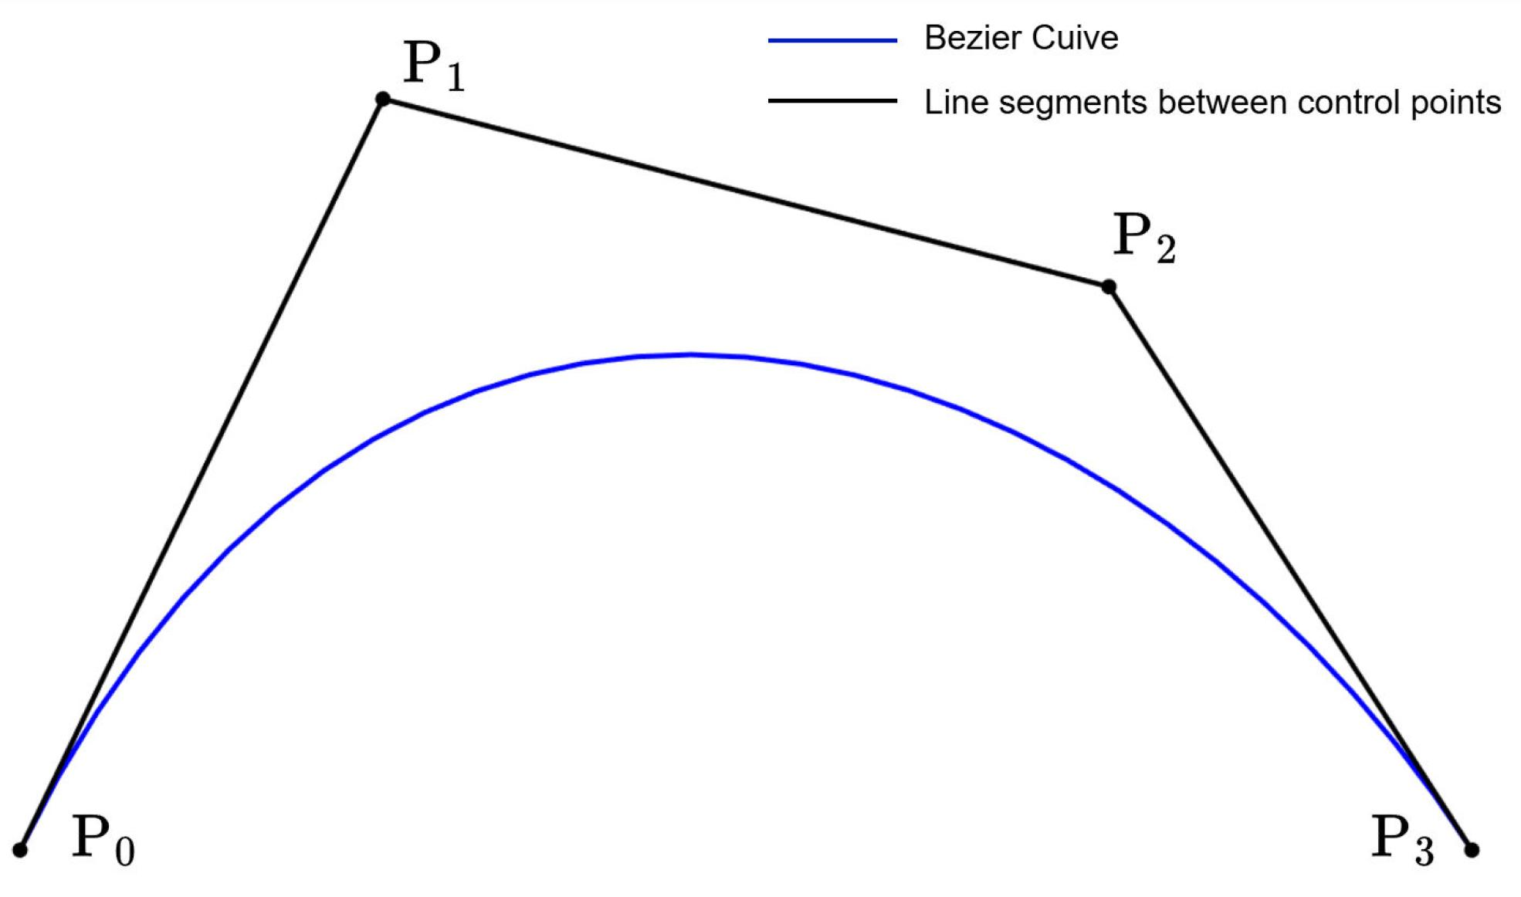
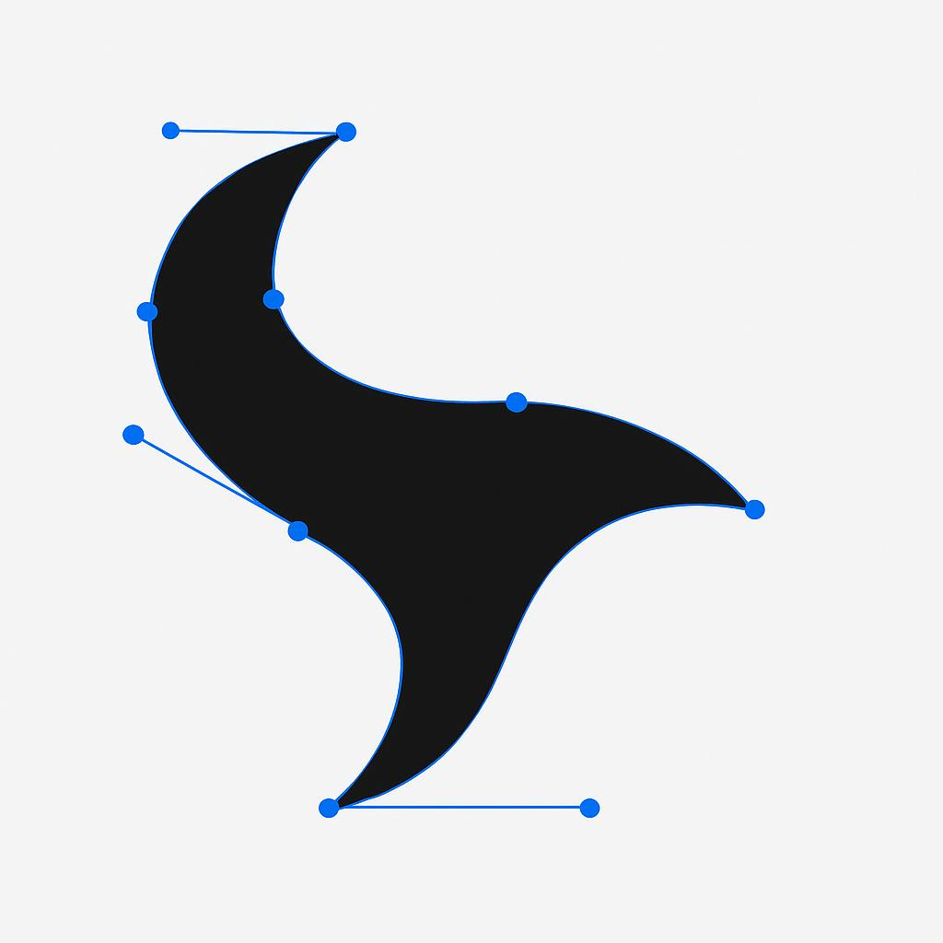
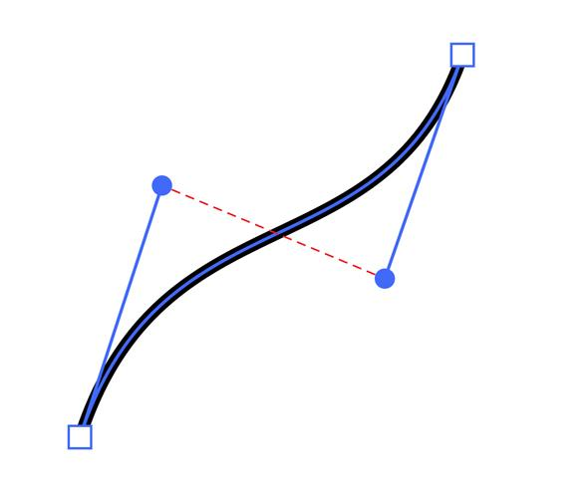
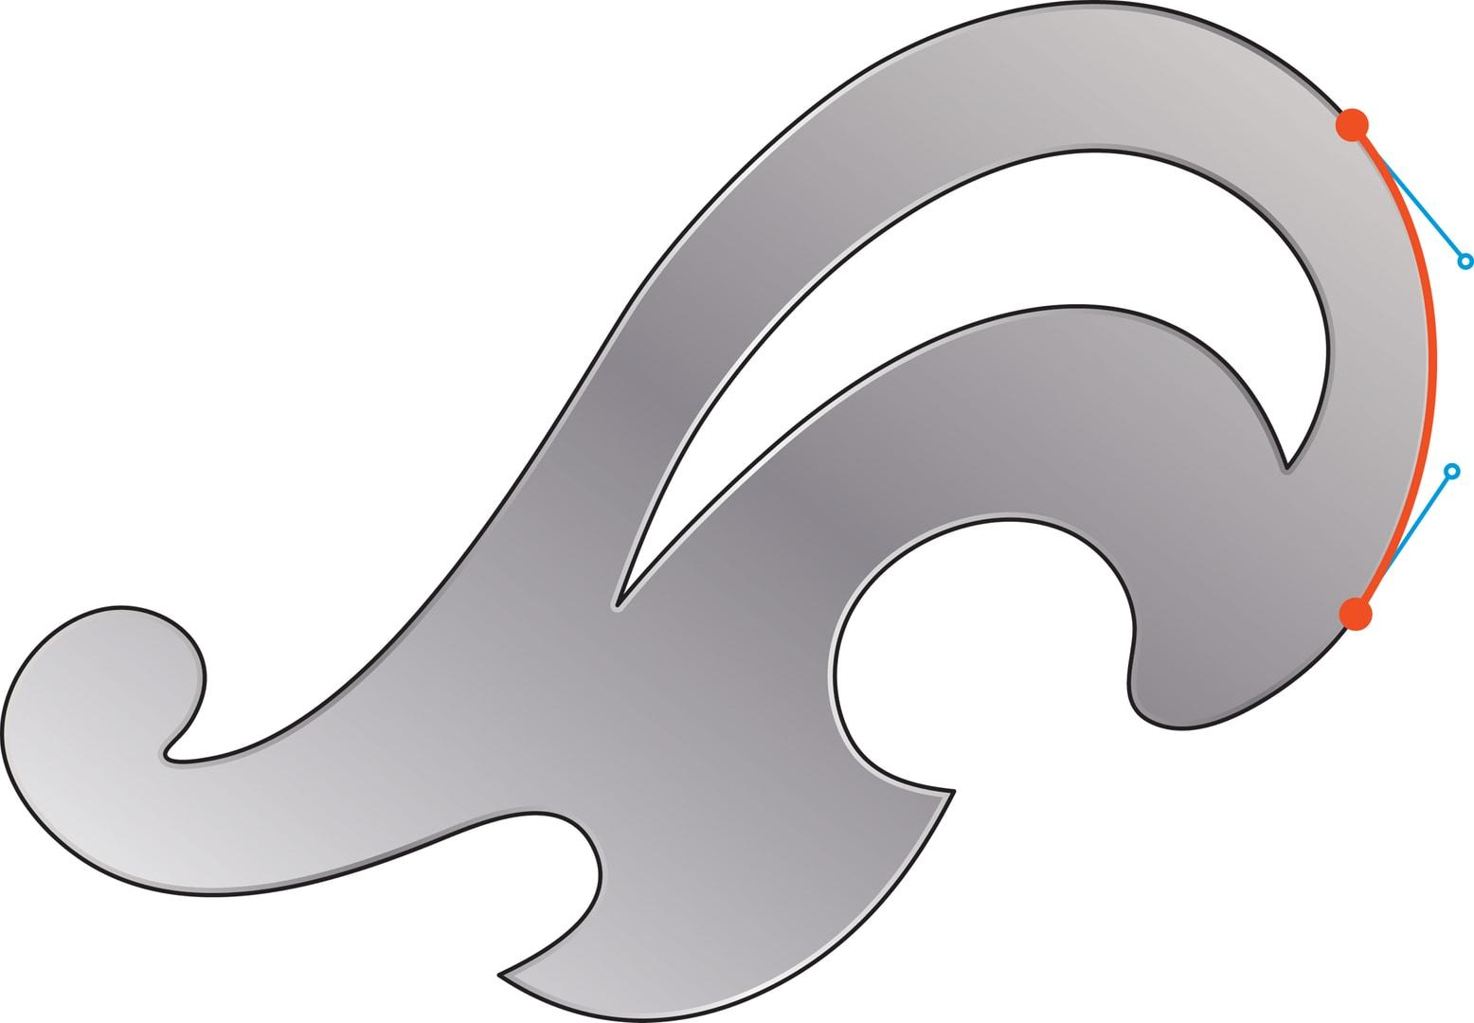
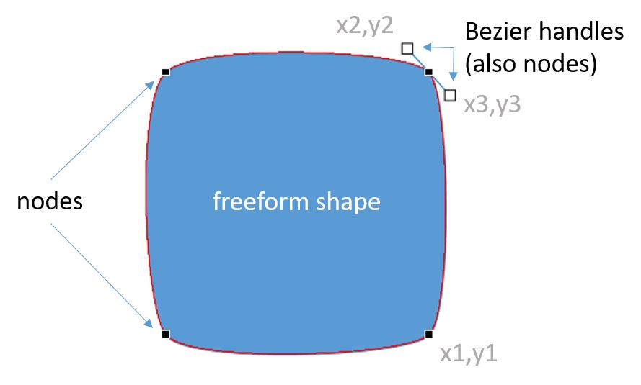
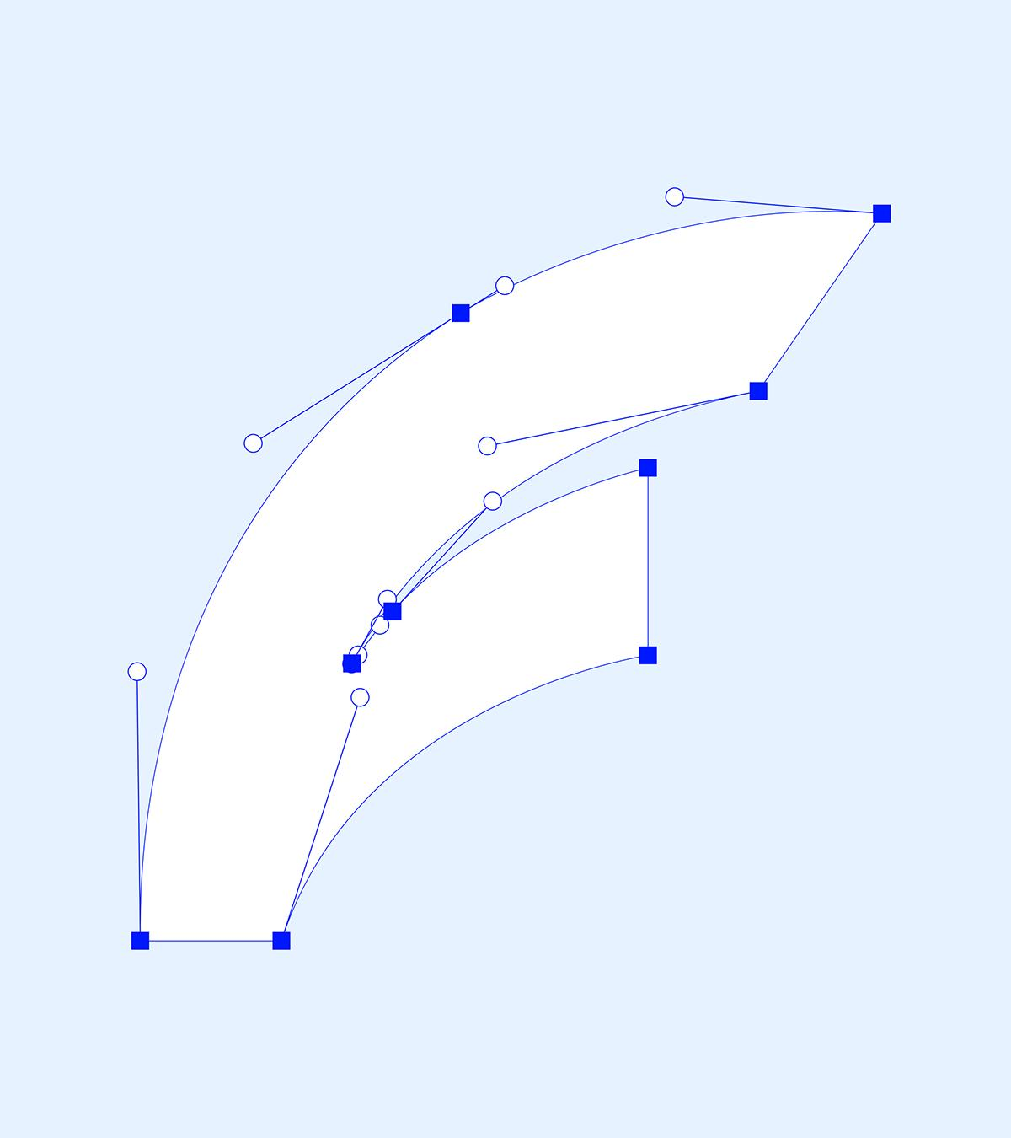

Freeform Curved Shapes vs. Standard Curves
# Source: AI Source: Provided by: [Data Path: Persons Table -> ID Column: 1, Name_En Column: Motasem Essam] -> From: [ChatGPT] on [7/25/2026]
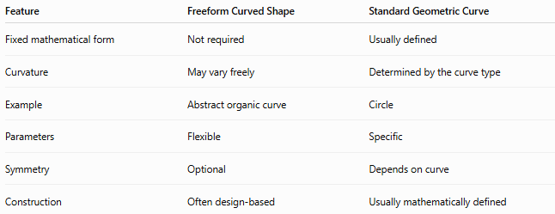
Feature | Freeform Curved Shape | Standard Geometric Curve
Fixed mathematical form | Not required | Usually defined
Curvature | May vary freely | Determined by the curve type
Example | Abstract organic curve | Circle
Parameters | Flexible | Specific
Symmetry | Optional | Depends on curve
Construction | Often design-based | Usually mathematically defined
For example:
$$x^{2}+y^{2}=r^{2}$$
is a circle and therefore has a precise standard mathematical definition.
A freeform curve does not have to satisfy such a standard equation.

Freeform Curved Shapes vs. Organic Shapes
# Source: AI Source: Provided by: [Data Path: Persons Table -> ID Column: 1, Name_En Column: Motasem Essam] -> From: [ChatGPT] on [7/25/2026]
These terms overlap but are not identical.
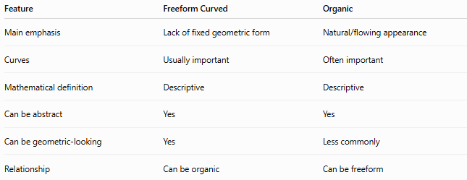
Feature | Freeform Curved | Organic
Main emphasis | Lack of fixed geometric form | Natural/flowing appearance
Curves | Usually important | Often important
Mathematical definition | Descriptive | Descriptive
Can be abstract | Yes | Yes
Can be geometric-looking | Yes | Less commonly
Relationship | Can be organic | Can be freeform
Therefore:
$$\text{Organic}≢\text{Freeform}$$
but many organic shapes are also freeform curved shapes.

Examples

Example 1 — Open freeform curve
# Source: AI Source: Provided by: [Data Path: Persons Table -> ID Column: 1, Name_En Column: Motasem Essam] -> From: [ChatGPT] on [7/25/2026]
A hand-drawn smooth path with two endpoints is an:
Open Freeform Curved Shape
It does not enclose an area by itself.

Example 2 — Closed organic blob
# Source: AI Source: Provided by: [Data Path: Persons Table -> ID Column: 1, Name_En Column: Motasem Essam] -> From: [ChatGPT] on [7/25/2026]
An irregular closed boundary resembling a natural stone is:
Closed + Organic + Freeform + Curved

Example 3 — Bézier-based shape
# Source: AI Source: Provided by: [Data Path: Persons Table -> ID Column: 1, Name_En Column: Motasem Essam] -> From: [ChatGPT] on [7/25/2026]
A shape created from several connected Bézier curves is:
Freeform + Curved + Mixed-Curve

Classification Summary
# Source: AI Source: Provided by: [Data Path: Persons Table -> ID Column: 1, Name_En Column: Motasem Essam] -> From: [ChatGPT] on [7/25/2026]
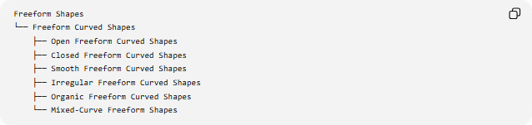
Freeform Shapes
└── Freeform Curved Shapes
├── Open Freeform Curved Shapes
├── Closed Freeform Curved Shapes
├── Smooth Freeform Curved Shapes
├── Irregular Freeform Curved Shapes
├── Organic Freeform Curved Shapes
└── Mixed-Curve Freeform Shapes
A structural classification can also be shown as:
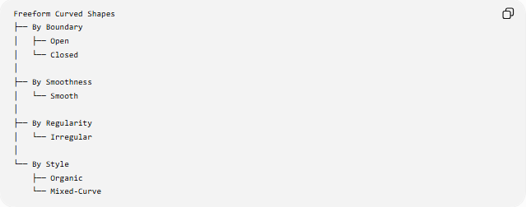
Freeform Curved Shapes
├── By Boundary
│ ├── Open
│ └── Closed
│
├── By Smoothness
│ └── Smooth
│
├── By Regularity
│ └── Irregular
│
└── By Style
├── Organic
└── Mixed-Curve
These categories are not mutually exclusive.

Key Points
# Source: AI Source: Provided by: [Data Path: Persons Table -> ID Column: 1, Name_En Column: Motasem Essam] -> From: [ChatGPT] on [7/25/2026]
- Freeform Curved Shapes have primarily curved boundaries without a fixed standard geometric form.
- They can be open or closed.
- Closed freeform curves can enclose measurable areas.
- Their curvature can vary along the boundary.
- They can be represented using explicit, implicit, parametric, or piecewise equations.
- Bézier curves are commonly used to construct freeform curves in digital design.
- Freeform does not necessarily mean irregular.
- Freeform does not necessarily mean organic.
- Organic freeform shapes emphasize natural or flowing appearance.
- The term is primarily descriptive, rather than a strict mathematical classification.

Conclusion
# Source: AI Source: Provided by: [Data Path: Persons Table -> ID Column: 1, Name_En Column: Motasem Essam] -> From: [ChatGPT] on [7/25/2026]
Freeform Curved Shapes are flexible curved forms whose boundaries are not restricted to a predetermined standard geometric shape. They can range from simple smooth open curves to complex closed organic forms constructed from multiple curve segments. Their mathematical representation is flexible, making them particularly useful in geometry, computer graphics, CAD, illustration, and design.

